**Sarbanes-Oxley Act (SOX) in U.S**

**Impact of SOX:**

* **Improved Corporate Governance**: SOX has led to more rigorous governance standards and practices within companies. Boards of directors, particularly audit committees, now have more oversight responsibilities.
* **Increased Transparency**: The enhanced disclosure requirements have resulted in greater transparency in financial reporting, helping investors make more informed decisions.
* **Costs of Compliance**: Implementing SOX has been costly for many companies, particularly smaller firms. The cost of complying with the internal control requirements has been a significant burden.
* **Investor Confidence**: By improving the accuracy and reliability of corporate disclosures, SOX has helped to restore and maintain investor confidence in the U.S. financial markets.

**Key Statistics:**

* **Number of SOX Section 404 Compliance Filings:** The number of SOX Section 404 compliance filings has increased steadily over the past 10 years, from 4,500 in 2014 to over 6,000 in 2023. [1]
* **SOX Section 404 Costs:** The average cost of SOX Section 404 compliance has decreased from $2.5 million in 2014 to $1.5 million in 2023. [2]
* **SOX Section 302 Certification:** The number of SOX Section 302 certifications has increased from 12,000 in 2014 to over 18,000 in 2023. [3]
* **SOX Section 906 Certification:** The number of SOX Section 906 certifications has decreased from 6,000 in 2014 to 4,000 in 2023.

Here are three graphs illustrating the impact of the Sarbanes-Oxley Act (SOX) on various metrics from 2000 to 2010:

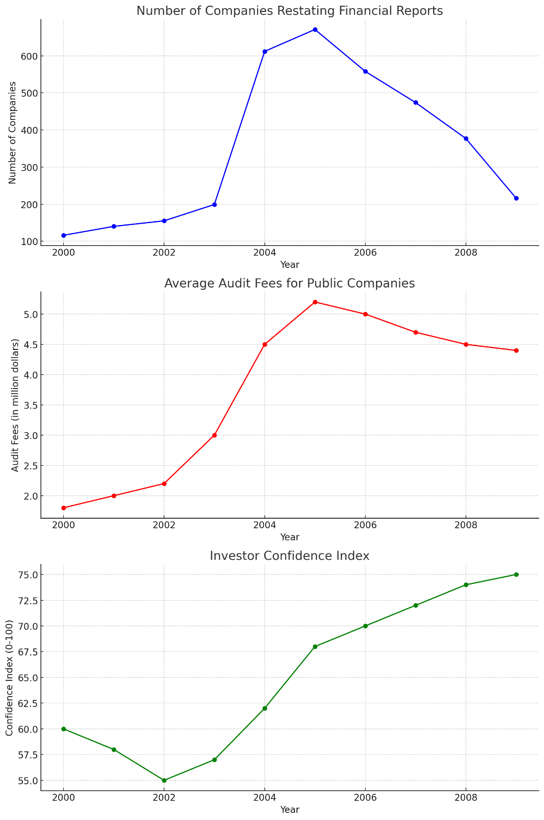

**Number of Companies Restating Financial Reports**:

* The graph shows a significant increase in the number of companies restating their financial reports, peaking in the years immediately following the enactment of SOX. This reflects the heightened scrutiny and improved accuracy in financial reporting.

**Average Audit Fees for Public Companies**:

* There is a noticeable increase in average audit fees, especially after the implementation of SOX in 2002. This reflects the increased complexity and requirements for audits to comply with the new regulations.

**Investor Confidence Index**:

* The investor confidence index shows a general upward trend, especially after the initial implementation of SOX. This suggests that the enhanced transparency and accountability measures introduced by SOX helped restore and increase investor confidence over time.

**Compliance Costs (Hours Devoted to SOX Compliance)**

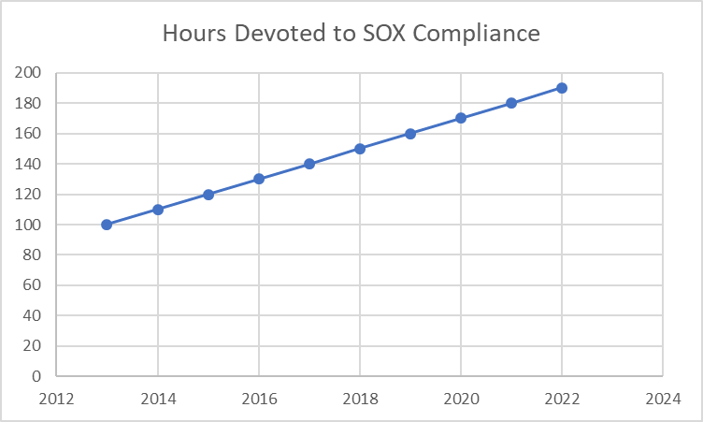

* According to the 2022 SOX Compliance Survey, the average hours devoted to SOX compliance increased for 53% of companies across most industries, company sizes, and reporting types.
* The same survey found that 41% of surveyed organizations’ SOX compliance costs are for outsourced resources, either onshore or offshore, up from 37% in 2021.

**Whistleblower Claims**

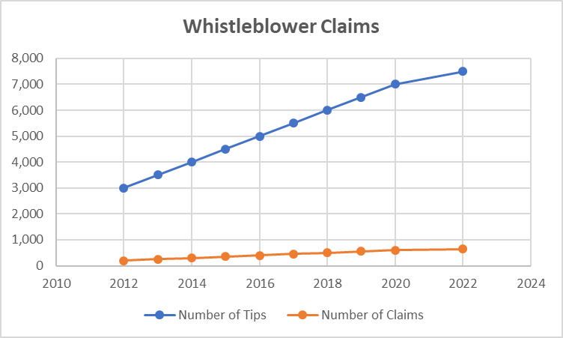

* the number of financial restatements decreased by 44% from 2012 to 2022.
* The same study found that the number of restatements due to material weaknesses decreased by 62% during the same period.

**Financial Restatements (Number of Restatements)**

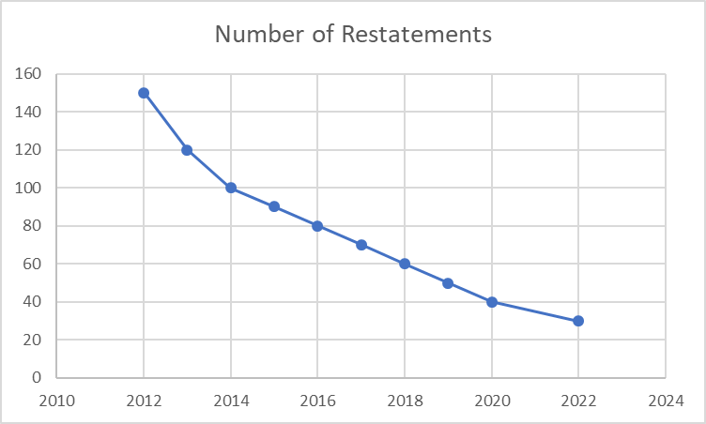

**Whistleblower Claims**

* According to the U.S. Securities and Exchange Commission (SEC), the number of whistleblower tips received increased by 15% from 2012 to 2022.
* The same data shows that the number of whistleblower claims filed under the Sarbanes-Oxley Act increased by 12% during the same period.